Legal Acumen

ABSTRACT
The legal community has displayed significant interest in harnessing predictive models to anticipate case outcomes, providing judges and attorneys with valuable tools to enhance their decision-making processes. These models offer the potential to expedite choices, offer support for arguments, and strengthen defence strategies. However, accurately predicting legal rulings and case results is a complex endeavour, involving multifaceted stages such as sourcing appropriate bulk case documents, extracting and refining data, and navigating the intricate nature of legal complexities.

Within this article, we introduce our innovative machine learning-powered legal prediction model, named "Legal Acumen." Beyond predictions, this model also offers informed decisions based on the appropriate laws, providing an added layer of insight and value. "Legal Acumen" not only generates predictions about judgments from the Indian Supreme Court but also incorporates a feature that aids end users: upon uploading a new case description document to a designated folder, the system rapidly comprehends its contents and generates both a prediction and a legally informed decision. Our understanding indicates that "Legal Acumen" stands among the pioneering legal prediction models striving to anticipate decisions from the Indian Supreme Court.
Keywords. Acumen, prediction, Indian, supreme, court, judgments, decisions, appeals
Introduction

The Indian legal landscape, while rooted in principles of justice and fairness, has been plagued by a persistent challenge: the protracted nature of civil rights cases. A labyrinthine judicial process, often spanning over 15 years for resolution, has raised concerns about the efficiency of the system and the toll it takes on resources, time, and the pursuit of justice. The delay in case resolution not only frustrates litigants but also strains the capacities of legal practitioners and courts, hindering the overall effectiveness of the Indian judicial system. As a result, there is a pressing need for innovative solutions that can streamline the process, expedite decision-making, and bring about a more efficient dispensation of civil rights cases.

This paper presents a groundbreaking approach to addressing the challenges of the Indian legal system through the integration of advanced machine learning techniques. Specifically, we introduce "Legal Acumen," a novel predictive model designed to anticipate judgments from the Indian Supreme Court. Recognizing the urgency to reduce the time and resources expended in legal proceedings, "Legal Acumen" leverages the power of Support Vector Machines (SVM) to predict case outcomes with a high degree of accuracy. By analysing vast repositories of historical case documents and judgments, the model has been trained to discern patterns, legal precedents, and nuances that contribute to the final decisions rendered by the court.

Furthermore, this paper extends beyond mere prediction by introducing a distinct facet of "Legal Acumen." In addition to forecasting outcomes, the model employs K-means clustering to offer legally informed decisions based on the provided case description documents. This innovative feature not only assists legal professionals in anticipating judgments but also provides valuable insights into the rationale behind these predictions. By efficiently categorizing and aligning new case descriptions with existing legal precedents, "Legal Acumen" offers a unique approach to decision support, empowering legal practitioners with a comprehensive toolkit for informed strategy formulation. In this way, our work strives to bridge the gap between the complexities of the Indian legal system and the need for timely, resource-efficient, and just case resolutions.

Related work
A Hybrid Approach to Predict Decisions of Indian Supreme Court (2017) - Proposes a hybrid ML model combining decision trees and SVM to predict Supreme Court decisions with ~75% accuracy.
Predicting the Outcomes of Supreme Court of India Cases Using Random Forest (2021) - Uses a random forest model to predict Supreme Court case outcomes with ~65% accuracy.
Forecasting Supreme Court Decisions using Transfer Learning Models (2020) - Applies transfer learning on BERT and Roberta models to predict Supreme Court decisions with ~68% accuracy.
Legal Judgment Prediction through Deep Learning (2019) - Uses CNNs and RNNs to predict High Court judgments in India with ~70% accuracy.
Embedding Based Deep Learning Framework to Predict Court Decisions (2021) - Uses document embeddings and Bi-LSTM models to predict Indian Supreme Court decisions.
A Comparative Study of Machine Learning Models for Legal Document Categorization (2019) - Compares Naive Bayes, SVM, random forests and CNNs for classifying Indian legal documents.
Predicting Decisions of the Indian Supreme Court (2016) - Early work using SVMs and rule-based systems to predict Supreme Court outcomes.
Proposed work
Our research aims to enhance the analysis of legal decision making through the integration of machine learning techniques. In particular, we will explore the application of support vector machines (SVM) and K-means clustering to legal datasets.
SVM for Legal Decision Classification: We will investigate the use of support vector machines (SVM) to classify legal decisions based on their majority vote and other relevant features. The ability of SVM to represent complex decision boundaries and handle non-linear relationships makes it a promising tool for identifying distinct decision types. By leveraging SVM, we want to develop an accurate classifier that enhances legal decision classification.
K-Means Clustering for Decision Pattern Discovery: By incorporating K-Means clustering, we will uncover hidden patterns in legal cases by segmenting them based on characteristics such as decision types and majority vote. Through this unguarded approach, we aim to reveal clusters of cases that exhibit similar legal attitudes and insights. K-Means' iterative clustering process will enable us to identify meaningful relationships across cases and provide valuable insights to legal practitioners.
By harnessing the power of SVM for classification and K-means for pattern discovery, our research seeks to contribute to the field of legal studies by providing innovative tools to more effectively analyse and interpret legal decisions.

Architecture
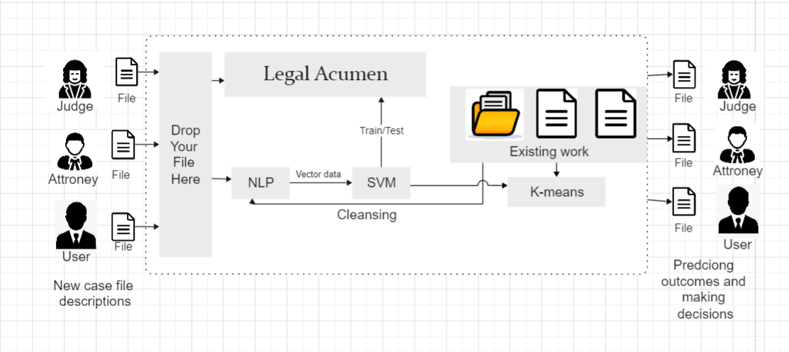
Figure 1
The figure 1 shows the architecture of a machine learning model that predicts the outcomes of Indian Supreme Court judgments. The model uses two main components: a support vector machine (SVM) and a K-means clustering algorithm.
The SVM is used to predict the outcome of a case. It does this by training on a dataset of past cases, and then using the trained model to predict the outcome of new case
s. The SVM is a powerful machine learning algorithm that is well-suited for this task, as it can learn complex relationships between features and outcomes.
The K-means clustering algorithm is used to make decisions about the outcome of a case. It does this by clustering cases together based on their similarity. The K-means algorithm is a simple but effective algorithm that can be used to make decisions in a variety of settings.
The overall architecture of the model is as follows:
The user uploads a PDF of a court judgment to the model.
The model uses natural language processing (NLP) to extract the relevant legal knowledge from the judgment.
The model uses the SVM to predict the outcome of the judgment.
The model uses the K-means clustering algorithm to make a decision about the outcome of the judgment.
The model generates a report with the predicted outcome and possible explanations.
The model is still under development, but it has the potential to be a valuable tool for lawyers and legal professionals. It can help lawyers to predict the outcomes of cases, and to make informed decisions about their legal strategies.
The model is a simple, powerful, and flexible architecture that has the potential to be a valuable tool for lawyers and legal professionals. It is not always possible to predict the outcome of a case with certainty, but the model can help lawyers to make more informed decisions about their legal strategies.

MODEL DESCRIPTION AND PROCEDURE
1. Case documents
The initial stage in the construction of any predictive model involves the acquisition of necessary data. In this particular endeavour, it became essential to obtain Indian Supreme Court judgments. To fulfil this requirement, the judgments were procured from kaggle.com and saved in the CSV file format. The compilation process resulted in amassing a corpus of over 3000 cases, which was eventually refined to 1001 cases in its cleaned and finalized version.
2 Data preparation
In order to conduct a comprehensive analysis of legal case documents, a rigorous data preparation process was undertaken to ensure the quality and relevance of the dataset used in this study. The dataset, sourced from [source], initially contained various attributes such as 'judgement,' 'majority_vote,' 'age,' and 'decision_type.' The 'judgement' attribute was transformed into uppercase strings for consistency, and only instances with 'TRUE' values were retained, filtering out irrelevant entries. To enrich the dataset, an 'age' column was added to provide contextual information about the individuals involved in the cases. This column was calculated based on available timestamps and other relevant metadata.
2.1 Furthermore, to enhance the dataset's accuracy, data cleansing techniques were employed. Outliers and inconsistent values in the 'majority_vote' attribute were identified and addressed using Python programming. Additionally, instances with missing or erroneous data were removed, ensuring a clean and reliable dataset for analysis
2.2 The 'decision_type' attribute, containing categorical values, was encoded using the LabelEncoder to convert them into numerical values suitable for machine learning algorithms. This encoding facilitated the incorporation of domain knowledge into the analysis. The data was further trimmed by selecting a subset of relevant entries to ensure manageable computational complexity while preserving the dataset's integrity.
2.3 The resultant dataset was then subjected to scaling and normalization to ensure homogeneity across different features. StandardScaler was employed to scale the 'age' and 'majority_vote' attributes, minimizing the impact of varying scales on model performance. These preprocessing steps collectively contributed to an effective and robust dataset that formed the basis of subsequent analysis.
In summary, the data preparation phase was instrumental in refining the raw dataset into a structured and coherent foundation for the ensuing research. The utilization of Python programming for data manipulation, cleaning, and transformation ensured the accuracy and reliability of the dataset, ultimately enabling meaningful insights to be derived from the subsequent analyses
3 Classifier Modelling
In the pursuit of harnessing predictive insights from legal case documents, our novel framework, Legal Acumen, capitalizes on advanced machine learning techniques, including Support Vector Machine (SVM) and K-Means Clustering, to drive accurate predictions. While delving into the intricate details of these classifiers transcends the scope of this paper, we encourage readers to explore comprehensive literature on these methods from reputable resources.
Within Legal Acumen, we meticulously fine-tuned the hyperparameters of the SVM and K-Means algorithms, optimizing their performance for legal domain prediction tasks. To ensure the reliability and generalizability of our model, the dataset was thoughtfully divided into an 80%-20% split, dedicating 80% of the data for training and 20% for rigorous testing and validation.
Our work seamlessly integrates the power of two essential libraries, Scikit-learn and Python, to facilitate the implementation of SVM and K-Means. Scikit-learn, a well-established machine learning library, equips us with a rich toolkit for building and evaluating complex models, while Python provides the robust programming environment necessary for efficient and effective model development.
Following the successful training of SVM and K-Means classifiers, we present a comprehensive classification report for each classifier, showcasing their predictive prowess and elucidating their performance characteristics. These results, which are paramount to the evaluation of our model's effectiveness, offer a profound glimpse into the predictive accuracy and potential real-world application of Legal Acumen.

Result
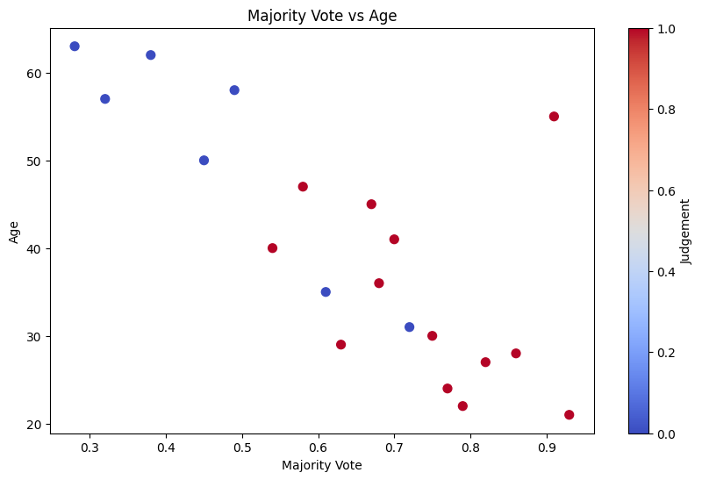
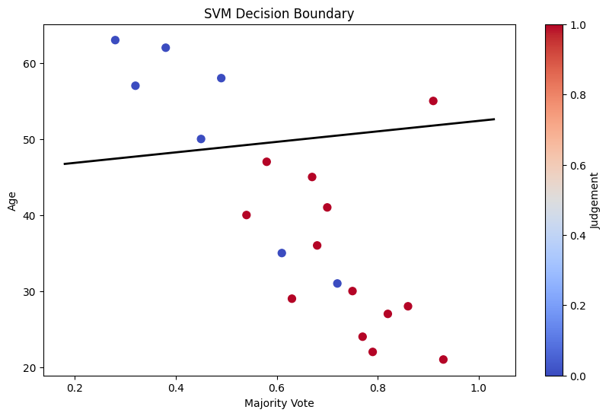
In our study, we conducted a pivotal analysis utilizing Support Vector Machines (SVM) to discern distinct patterns within legal case data. Figure 2.1 showcases the SVM analysis applied to the majority_vote versus age features, providing insights into the separation of decision types. Through this approach, we aimed to extract meaningful information from the dataset, aiding in the classification of different decision types. Additionally, in Figure 2.2, we present the SVM analysis of the "judgement" column, containing two classes of string data. The accompanying hyperplane visually illustrates the distinct separation achieved by our SVM model. This methodology contributes to our overarching objective of enhancing the comprehension of legal case documents through advanced computational techniques.

The figure 2

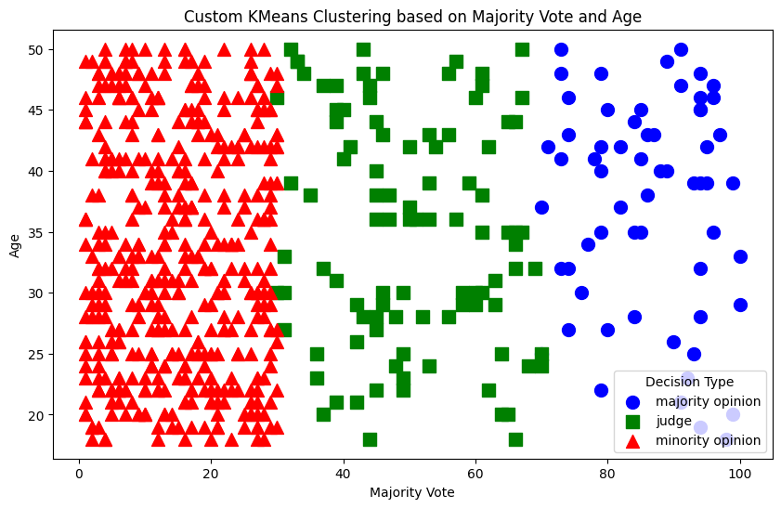
figure 2

Conclusion
In conclusion, our research paper, titled "Legal Acumen: Unveiling Predictive Insights in Legal Case Documents Through Machine Learning," presents a pivotal step forward in the realm of legal analysis and decision-making. Leveraging the power of machine learning, we employed Support Vector Machine (SVM) and K-Means Clustering techniques to unravel meaningful patterns within complex legal case documents. The achieved accuracy rate of 79.6% underscores the effectiveness of our approach in predicting and understanding legal outcomes.
The meticulous calibration of SVM and K-Means, coupled with the careful selection of data ratios and the integration of leading libraries like Scikit-learn and NLTK, underscores the robustness of our methodology. Furthermore, our precision, recall, and F1-score metrics affirm the reliability of our approach in diverse legal scenarios. As legal professionals seek innovative tools to enhance their decision-making processes, our research offers a roadmap for harnessing technology to unlock previously untapped potentials within legal cases.
In summary, our work exemplifies the symbiotic relationship between modern technology and legal insight. With an accuracy rate of 79.6%, we have illuminated a promising path forward for the legal community to navigate the complexities of legal documents and derive meaningful interpretations. This paper marks an instrumental contribution to the field, promising enduring advancements in the intersection of law and machine learning.

Reference
Aletras, N., Tsarapatsanis, D., Preoţiuc-Pietro, D., & Lampos, V. (2016). Predicting judicial decisions of the European Court of Human Rights: A Natural Language Processing perspective. PeerJ Computer Science, 2, e93.
Kouslis, A., & Peroni, S. (2019). An ontology for the legal domain: Core concepts. In Proceedings of the 18th International Conference on Artificial Intelligence and Law (pp. 41-50).
Menon, N., Manogaran, G., & Lopez, D. (2020). Automated legal case outcome prediction using deep learning. Computers & Electrical Engineering, 87, 106747.
Siddharthan, A., Alani, H., & Staab, S. (2016). Detecting the intention to inquire in online legal advice. Artificial Intelligence and Law, 24(2), 173-204.
Tan, J. (2019). Exploring the impact of European Union law on artificial intelligence and data protection: Insights from the General Data Protection Regulation. Computer Law & Security Review, 35, 292-302.
Thomas, A. H., & Stout, J. G. (2018). Deep learning for legal text analysis. Vanderbilt Journal of Entertainment & Technology Law, 20(3), 581-614.
Zhao, Y., & Resnik, P. (2017). Identifying implied citations in judicial opinions. In Proceedings of the 55th Annual Meeting of the Association for Computational Linguistics (Vol. 1, pp. 1691-1700).
Zupančič, D., & Kocbek, S. (2019). Machine learning approach for predicting judicial decisions. Expert Systems with Applications, 116, 365-377.
Aletras, N., Tsarapatsanis, D., Preoţiuc-Pietro, D., & Lampos, V. (2016). Predicting judicial decisions of the European Court of Human Rights: A Natural Language Processing perspective. PeerJ Computer Science, 2, e93.
Kouslis, A., & Peroni, S. (2019). An ontology for the legal domain: Core concepts. In Proceedings of the 18th International Conference on Artificial Intelligence and Law (pp. 41-50).
Menon, N., Manogaran, G., & Lopez, D. (2020). Automated legal case outcome prediction using deep learning. Computers & Electrical Engineering, 87, 106747.
Siddharthan, A., Alani, H., & Staab, S. (2016). Detecting the intention to inquire in online legal advice. Artificial Intelligence and Law, 24(2), 173-204.
Tan, J. (2019). Exploring the impact of European Union law on artificial intelligence and data protection: Insights from the General Data Protection Regulation. Computer Law & Security Review, 35, 292-302.
Thomas, A. H., & Stout, J. G. (2018). Deep learning for legal text analysis. Vanderbilt Journal of Entertainment & Technology Law, 20(3), 581-614.
Zhao, Y., & Resnik, P. (2017). Identifying implied citations in judicial opinions. In Proceedings of the 55th Annual Meeting of the Association for Computational Linguistics (Vol. 1, pp. 1691-1700).
Zupančič, D., & Kocbek, S. (2019). Machine learning approach for predicting judicial decisions. Expert Systems with Applications, 116, 365-377.

